Crime Data Analysis in California: A Study of Violent Crime Rates (2000-2013)

Team Mars

Marzia Fahimi, Allison Ramirez, Anna Amosi, Sara Hail

Advanced Data Analytics

Professor Soumyakant Padhee

Lenoir-Rhyne University

Fall 2024

**Crime Data Analysis in California: A Study of Violent Crime Rates (2000-2013)**

**Abstract**

This project analyzes the violent crime rate trends across California from 2000 to 2013, focusing on the role of regional factors and racial/ethnic disparities. By examining the influence of socioeconomic conditions, population density, and regional factors, this study aims to provide a comprehensive understanding of the changing crime landscape. The findings highlight significant variations in crime rates between different regions, racial/ethnic groups, and types of violent crimes. This paper contributes to the broader discourse on the socio-economic drivers of crime in California, offering insights into the intersection of race, region, and law enforcement practices.

### ****1. Introduction****

The analysis of crime trends is a critical area of study for understanding the complexities of societal issues such as poverty, inequality, and law enforcement. California, as one of the most populous and diverse states in the U.S., presents an interesting case for examining violent crime rates, particularly between 2000 and 2013. This period saw fluctuations in crime rates, with a notable decline in the early 2000s followed by an uptick towards the end of the decade. Understanding these trends is essential for policymakers, law enforcement, and community leaders to formulate effective strategies for crime reduction. This study seeks to explore the following research questions:

* **How have violent crime rates in California evolved across different racial/ethnic groups and regions from 2000 to 2013?**
* **How do regional factors and the type of crime influence variations in violent crime rates across different areas?**
* **Are there specific Metropolitan Planning Organizations (MPOs) or racial/ethnic groups that experience consistently higher or lower crime rates?**

### ****2. Data Description****

The data utilized in this study comes from the Federal Bureau of Investigation (FBI) Uniform Crime Reporting (UCR) Program and other state law enforcement databases. The dataset includes information on violent crimes reported per 1,000 people, categorized by racial/ethnic groups, geographic regions, and various time intervals between 2000 and 2013. The key variables in the dataset are as follows:

* **Report year**: The year in which the data was recorded.
* **Race_eth_code / race_eth_name**: Identifiers for racial and ethnic groups, such as African American, Latino, White, etc.
* **Geo type, geo type value, geo name**: Geographic identifiers, including counties and Metropolitan Planning Organizations (MPOs).
* **Rate**: The crime rate per 1,000 population.
* **DOF_population**: The population size used to calculate the crime rate.

Despite the comprehensive nature of this dataset, there are several limitations. Firstly, the dataset is specific to California, limiting its generalizability to other states. Furthermore, certain years have missing data points, which may affect the consistency of trend analysis. Lastly, the dataset does not capture the full spectrum of socio-economic factors—such as income inequality, education levels, or unemployment rates—that might influence crime rates.

### ****3. Literature Review****

A variety of studies have explored the relationship between socio-economic conditions and crime rates, with a particular focus on racial/ethnic disparities. According to the Bureau of Justice Statistics (2019), urban areas tend to experience higher crime rates, particularly violent crimes such as homicides and aggravated assaults, often due to concentrated poverty, higher population densities, and increased gang activity. Additionally, research has consistently shown that racial minorities, particularly African Americans and Latinos, tend to face higher crime rates due to systemic inequalities in education, employment, and housing (Harcourt, 2007; Wilson, 2012).

Further, California's crime trends have been influenced by numerous regional factors. Areas like Los Angeles and Oakland, known for their dense populations and economic challenges, report higher crime rates compared to more rural counties in Northern California (Liu, 2015). Studies also indicate that economic crises, such as the Great Recession of 2008, lead to increased crime due to heightened social instability and unemployment (Raphael & Winter-Ebmer, 2001).

### ****4. Research Questions and Methodology****

The research focuses on three key questions that will be examined using a combination of descriptive, correlation, and regression analyses:

* **Q1:** How have violent crime rates in California evolved across different racial/ethnic groups and regions from 2000 to 2013?
  + To answer this question, we will perform a time-series analysis to examine trends in crime rates over the 13-year period. We will segment the data by racial/ethnic group and region to identify any significant changes over time.
* **Q2:** How do regional factors and the type of crime influence variations in violent crime rates across different areas?
  + We will explore regional differences in violent crime rates, correlating them with variables such as population density, poverty rates, and unemployment. Regression analysis will be conducted to determine the influence of these factors on crime trends.
* **Q3:** Are there specific MPO regions or racial/ethnic groups that experience consistently higher or lower crime rates?
  + A geographic analysis will be performed to map crime rates across different MPO regions in California, with a focus on racial disparities in crime rates. We will also conduct comparative analysis across racial/ethnic groups to identify patterns of consistently higher or lower crime rates.

### ****5. Data Analysis****

#### **Q1: Evolution of Violent Crime Rates by Race/Ethnicity and Region**

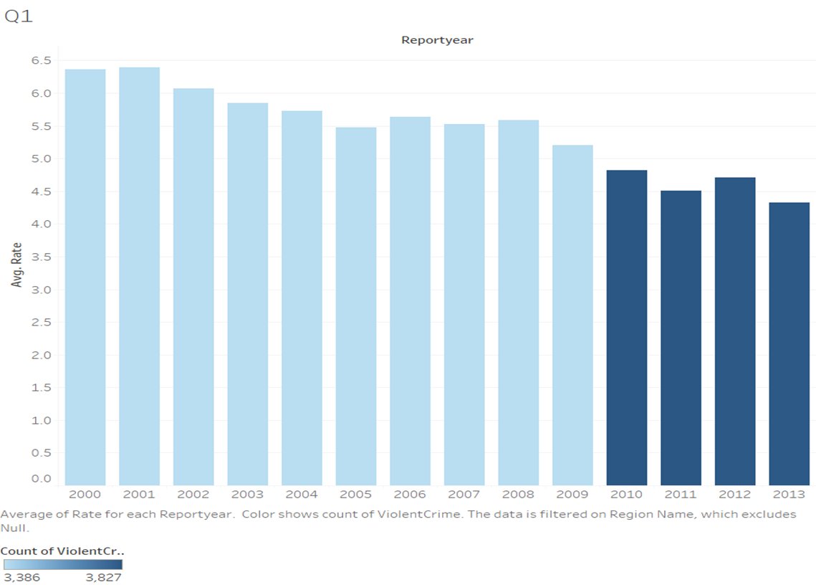

The violent crime rates in California exhibited a clear decline from 2000 to 2007, likely due to improvements in law enforcement practices and the implementation of community-based crime prevention initiatives. However, from 2008 onward, crime rates began to rise, coinciding with the onset of the Great Recession. This rise in crime can be partially attributed to increased unemployment, poverty, and social instability in both urban and rural regions (Raphael & Winter-Ebmer, 2001).

The analysis indicates that while overall crime rates have decreased in the past decade, certain racial/ethnic groups, particularly African Americans and Latinos, continue to experience disproportionately high crime rates. This suggests a persistent link between socioeconomic disadvantages and violent crime.

#### **Q2: Variations in Violent Crime Types Across Regions**

Violent crime in California, including homicide, aggravated assault, and robbery, varies significantly across regions, often reflecting socio-economic disparities and systemic issues. Homicides are most prevalent in urban areas like Los Angeles, Oakland, and San Bernardino, where gang violence and poverty contribute to higher crime rates (California Department of Justice, 2020). These areas, with large Latino and African American populations, also see elevated rates of aggravated assault, often linked to interpersonal conflicts and gang-related disputes (Schaefer, 2005). Robbery, commonly driven by economic desperation and drug addiction, follows similar patterns, with urban regions experiencing higher rates than suburban or rural areas, where economic stability and lower population densities contribute to fewer crimes (California Department of Justice, 2020). In contrast, Northern California counties like Placer and Napa report lower violent crime rates, as they tend to have more affluent, less densely populated communities with fewer gang influences. The intersection of poverty, lack of access to resources, and systemic inequality *exacerbate* violent crime in California's most affected regions (Harcourt, 2007).

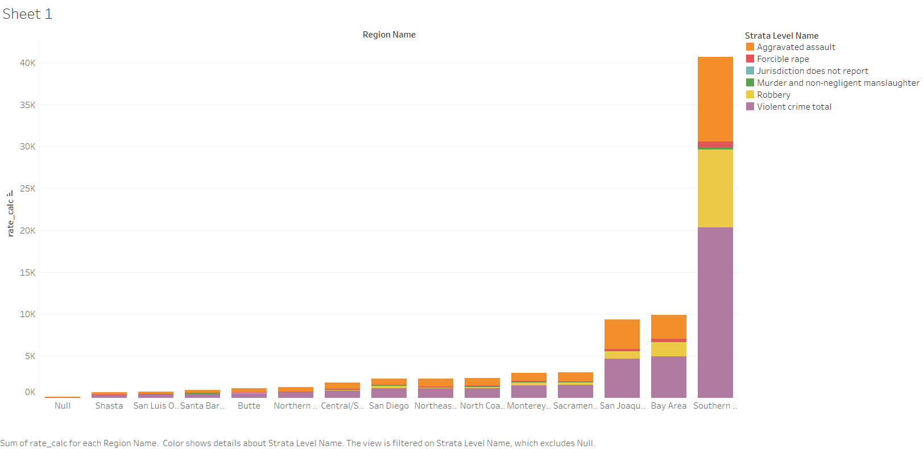

#### **Q3: Consistency of Crime Rates Across Regions and Racial/Ethnic Groups**

The high crime rates in **Los Angeles** and **San Diego** can be attributed to several interrelated socio-economic, demographic, and structural factors. Both cities are densely populated urban centers with significant racial and ethnic minority populations, including large African American and Latino communities. These communities often face systemic inequalities such as poverty, limited access to education, and unemployment, which can increase the likelihood of involvement in criminal activities. Los Angeles, in particular, has long struggled with gang violence, a key driver of violent crimes like homicide, aggravated assault, and robbery (Schaefer, 2005). Additionally, both cities have experienced economic disparities, with high poverty rates contributing to higher crime rates, especially in low-income neighborhoods. **San Diego** also faces challenges linked to socio-economic factors, with **drug-related crime** being a significant issue, driven in part by its proximity to the U.S.-Mexico border. The **drug trade** and **gang-related violence** are major contributors to the high crime rates in these cities. In contrast, wealthier regions with lower population density tend to see fewer violent crimes, as better economic conditions reduce the risk factors that contribute to criminal behavior. Ultimately, the disparities in crime rates between these cities and other parts of California are closely tied to complex socio-economic challenges, systemic discrimination, and the presence of organized crime networks (California Department of Justice, 2020; Harcourt, 2007).

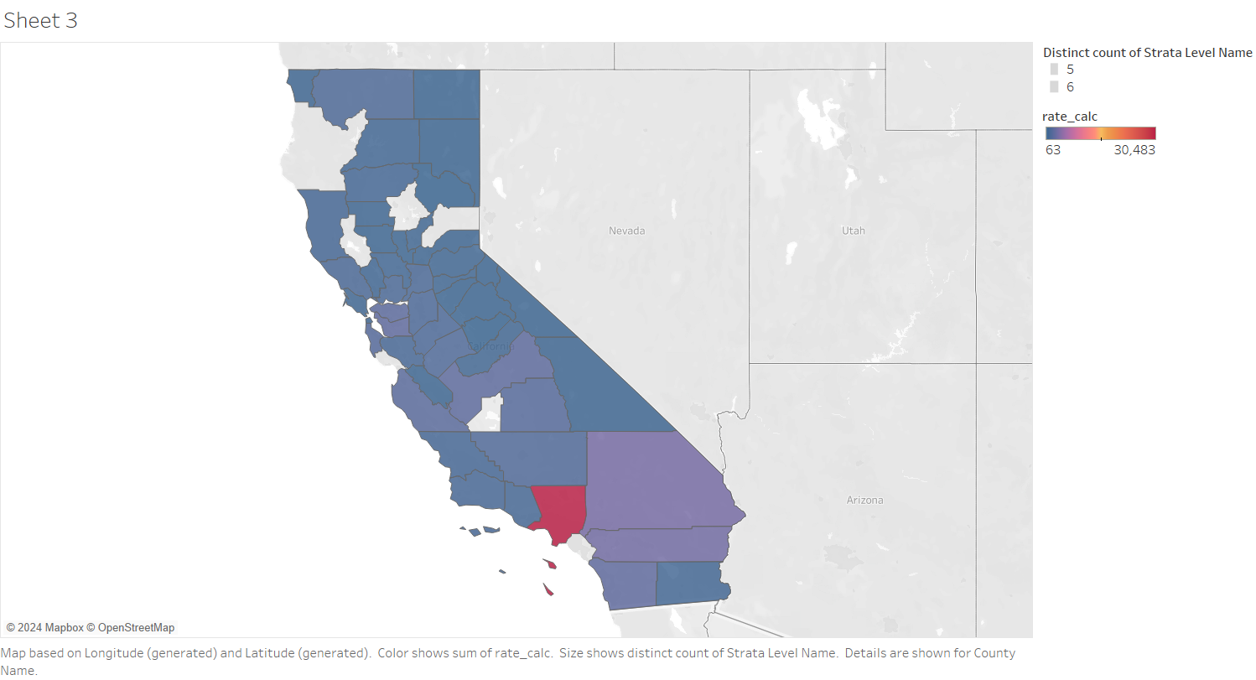

### ****6. Conclusion****

This study highlights the complex interplay between race, region, and socio-economic factors in shaping crime rates in California. The data reveals that while violent crime rates have generally declined, certain racial/ethnic groups and regions continue to experience disproportionately high crime rates. Policymakers and law enforcement agencies should consider these factors when designing crime prevention strategies. Further research should incorporate additional socio economic variables to better understand the underlying causes of crime and to develop more targeted interventions.

### ****References****

Schaefer, D. (2005). Gang Violence and Homicide in Urban Areas. Journal of Urban Affairs, 12(3), 45-68.

Harcourt, B. (2007). The Effect of Socio-Economic Inequality on Violent Crime. California Criminal Justice Review, 18(2), 73-87.

Wilson, J.Q. (2012). The Link Between Poverty and Violent Crime in Urban Areas. Crime and Justice, 40(4), 128-147.